2018 Park City Farmers Market Operational Specifics

Dates and Times of Operation
- Wednesdays, June 13 – October 17, 2018 (no Market on July 4th ,2018)
- Market open 12:00 p.m. – 5:00 p.m.
- Set-up begins at 10:00 a.m. and breakdown is by 6:00 p.m.

Attendance
The applicant reports that the average person attends the market for 30 – 45 minutes. Weekly attendance is 300 – 500 visitors per day during the shoulder season, averaging 100 – 150 people at any one time; and 1000 – 1500 per day at the peak months of July and August.

Vendor Mix
PCFM is comprised of a maximum of 80 vendor booths including up to four food vendors with the following breakdown:
- 35% Farmers (28 vendors);
- 25% packaged and prepared ‘Utah’s Own’ products (20 vendors) ;
- 15% jewelry (12 vendors);
- 15% Home improvement (12 vendors) ;
- 10% miscellaneous (Native Indian, Armed Services, Non Profit, Voter Registration, etc. (8 vendors);

All farmers are pesticide free and each is inspected by Mr. Ritzinger yearly for compliance. PCFM allows non-profit organizations to participate for no costs. There is no limit to how many times a non-profit group can attend the market in a season.

Live Music
The event would offer live music, from 12:00 – 3:00 p.m. as a supplement to the event on the following days:
- July 11, 18, 25,
- August 1, 8,15, 22, 29
The music setup is on-grade with no stage and oriented away from the adjacent buildings. The applicant has requested and received permission for a variance for noise variance up to 90 decibels as per Park City Municipal Code 6-3-11. In coordination with PCPD, any noise complaints will be enforced as per the Park City Municipal Code 6 -3-14.

Beer Sales
Vail Resort will apply for a UDABC and Park City permit to serve beer during this busier period of mid-July and August. These dates have not yet been applied for or confirmed.

Environmental Sustainability
The PCFM staff manages its own waste and recycling. The organizer will be supplying paper bags for use. The use of plastic bags by farmers is being discouraged and being phased out during this season. Through its social media presence the organizer and farmers will encourage attendees to bring their own reusable bags to the event. PCFM will report weekly and end- of season waste and recycling statistics to Staff.

Transportation, Parking and Transit Impacts
- Through its social media presence the organizer will encourage attendees to use the transit system and carpool to the event.
- The location of the event is held on existing City transit routes and ample parking. No additional transit or parking needs are expected at this time.
- The anticipated amount of vehicles associated with this event is minimal.
- The applicant will have 2 staffed crosswalk locations at Lowell and Silver King/First Time lots to assist with safe crossing for attendees.
- The organizer will create ADA parking area adjacent to the Silver King Lot
- Vendor will park their vehicles adjacent to their booths or in the First Time Parking Lot
- The organizer will be responsible for maintaining the parking lots for their use
- Staff will monitor transportation and parking throughout the market season and the organizer will be required to create a transportation plan if overflow parking becomes a problem outside of the off street parking areas.

Volker Ritzinger, owner of the Market, will continue to lease at the Silver King Lot and use of adjacent parking from Vail Resort for one year. The markets mission is to provide the highest quality local produce to the community, with no intention to increase its total vendor numbers.

Staff finds that there is ample parking to accommodate the estimated crowd and room to park additional vehicles if attendance increases.
- Residents and visitors within Park City will be encouraged by the organizer and pushed out on their social media platforms.
- All major Park City Transit routes routinely pass this location servicing the entire community.
- The number of potential transit riders is within our systems capacity.
- Two staffed crosswalk locations will be added to Lowell Ave between the Silver King and First Time Lots to provide safe crossing for attendees.
- The organizer will also be creating an ADA only parking area adjacent to the market in the Silver King Lot.

Safety. Security & Weather
Staff finds that no security challenges for this event and no Park City Police Department offers will be required to staff the event at this time. The organizers will have two private security people on site at each market. PCPD or the organizer shall have the right to cancel the events based on weather or other identifiable security concerns.

Other events on proposed dates in Park City
DATE ( Wednesday) | EVENT | A – Geographic  Separation | B - Proposed  Time & Duration | C – Anticipated  Attendance
June 13 – October 17, 2018 ( excluding July 4th ) | Park City Farmers Market | Silver King Parking Lot, First Time Lot , Pack City Base Parking | 12:00pm – 5pm | 500 people
June 20 – August 22, 2018 | Wednesday Night Concert @ Deer Valley | Snow Park Amphitheatre | 6:00pm – 8:00pm | 2,000 people
July 11 & 18, 2018 | Triple Crown | Quinn’s Sports Complex, PC High School and TMS Fields | 8:00 a.m. – 8:00 p.m. | 500 people per complex per day

Estimated City Service Fees for 2018
  - No fee waivers will be requested for the 2018 event. The event will pay for the fees as listed.

DEPARTMENT | Costs/ Estimate
Special Event Application Fee | $160.00
Building Permit & Inspection Fees for 17 markets ( estimated at $75.00 per market day) | 1,275.00
Facility/ Equipment Rental | 0.00
Fields/Park Rentals | 0.00
Special Use Parking | 0.00
Bleacher Rental | 0.00
Trail Fees | 0.00
Public Safety Personnel | 0.00
Total Estimated Fees | 1,435.00

Special Event Advisory Committee (SEAC) Review
SEAC met and discussed the PCFM at the April 18,, 2018 meeting. The committee forwarded a favorable recommendation based on it being a compelling community activity and gathering place. See image from SEAC notes below:
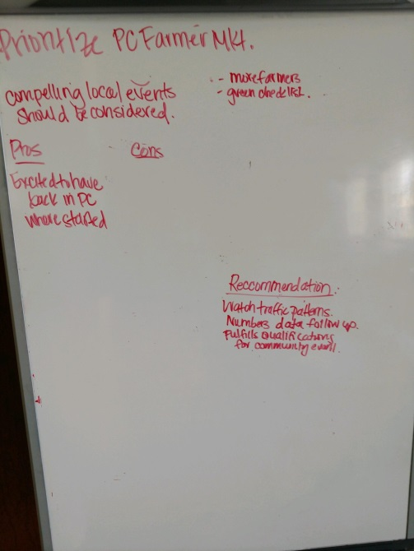

Overall Event Site Plan

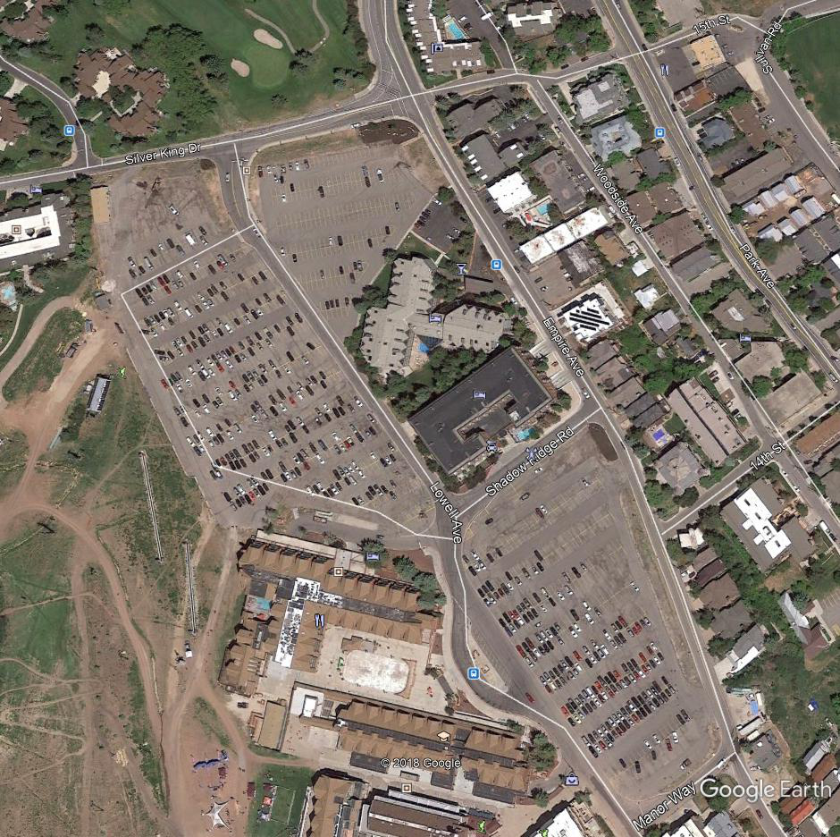

First Time Lot 640 Spaces
EVENT SPACE
Main Lot 417 Spaces

Market Layout and Set-up

